**HAND TRACKING**

USING OPENCV AND MEDIAPIPE

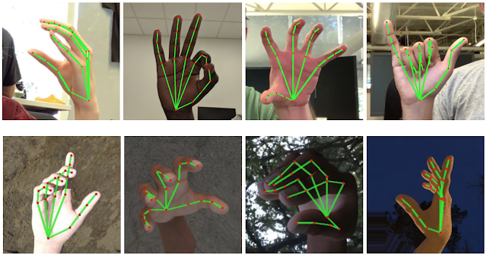horizontal line

# 

# Introduction

This project is made using python, and I used OpenCV and mediapipe for hand recognition and hand tracking. Hand tracking is useful for forming the basis for sign language understanding and hand gesture control, and can also enable the overlay of digital content and information on top of the physical world in augmented reality.

## Workflow

Initially, I approached the project in the following sequence:

* Getting the webcam feed
* Recognizing the palm
* Tracking the landmarks of the palm
* Drawing lines and circle on those tracking landmarks

I used OpenCV for getting my webcam feed. I converted that from BGR to RGB using OpenCV. Then I tracked the landmarks using mediapipe library.MediaPipe Hands utilizes an ML pipeline consisting of multiple models working together: A palm detection model that operates on the full image and returns an oriented hand bounding box. A hand landmark model that operates on the cropped image region defined by the palm detector and returns high-fidelity 3D hand keypoints. And finally, I draw the landmarks on the hand using OpenCV.